Ansible Challenge
Create ci pipeline that will deploy and configure these VMs using terraform and ansible according following requirements
- Deploy 2 virtual machines using terraform.
  - first vm on Amazon linux, hostname: c8.local
  - second vm on ubuntu 21.04, hostname: u21.local
- As a result of terraform execution, dynamically create inventory for ansible
  - c8.local should be in the frontend group
  - u21.local should be in the backend group
- Create ansible playbook for c8.local and u21.local
- for linux OS playbook should apply the following changes
  - selinux: disable
  - firewalld: disable
- for frontend playbook group should install and configure nginx
  - nginx configuration should do proxying from port 80 on port 19999 to the
  - backend group
- for the backend group, the playbook must install the Netdata application from the
  - official repositories and run it on port 19999.

Task Title
Automated Infrastructure Provisioning and Monitoring using Terraform + Ansible + Jenkins
Objective
To design and implement a CI/CD pipeline that:
- Provisions two EC2 instances using Terraform
  - Frontend (Amazon Linux – Nginx reverse proxy)
  - Backend (Ubuntu – Netdata monitoring)
- Automatically configures servers using Ansible
- Deploys Netdata on backend and exposes it via:
  - Direct access on port 19999
  - Reverse proxy via Nginx on frontend
- Orchestrates everything using Jenkins Pipeline
- Achieves fully automated deployment from GitHub source code
Prerequisites
- AWS account with IAM access keys
- Jenkins server with:
  - Git
  - Terraform
  - Ansible
  - SSH Agent Plugin
  - AWS Credentials configured
- EC2 key pair (.pem)
- GitHub repository (public)
- Security Groups allowing:
  - SSH (22)
  - HTTP (80)
  - Netdata (19999)

Architecture Overview
User Browser
|
| HTTP :80
v
Frontend EC2 (Amazon Linux)
Nginx Reverse Proxy
|
| HTTP :19999 (internal)
v
Backend EC2 (Ubuntu)
Netdata Service

GitHub Repository Structure
ansible-challenge/
│
├── ansible/
│ ├── common.yml
│ ├── backend.yml
│ └── frontend.yml
│
├── terraform/
│ ├── provider.tf
│ ├── ec2.tf
│ └── inventory.tf
│
├── Jenkinsfile
└── README.md

Step-by-Step Implementation:
Step 1: Create GitHub Repository
- Repository name: ansible-challenge
- Visibility: Public
- Added README
- Pushed Terraform, Ansible, and Jenkinsfile
Step 2: Terraform – Infrastructure Provisioning
provider.tf
provider "aws" {
region = "us-east-1"
}
ec2.tf
resource "aws_instance" "frontend" {
ami = "ami-xxxxxxxx"
instance_type = "t2.micro"
key_name = "NV"
tags = {
Name = "frontend"
}
}

resource "aws_instance" "backend" {
ami = "ami-yyyyyyyy"
instance_type = "t2.micro"
key_name = "NV"
tags = {
Name = "backend"
}
}
Step 3: Terraform – Dynamic Ansible Inventory
inventory.tf
resource "local_file" "ansible_inventory" {
filename = "../ansible/inventory.ini"

content = <<EOF
[frontend]
c8.local ansible_host=${aws_instance.frontend.public_ip} ansible_user=ec2-user

[backend]
u21.local ansible_host=${aws_instance.backend.public_ip} ansible_user=ubuntu

[backend:vars]
backend_ip=${aws_instance.backend.private_ip}
EOF
}
Fix applied:
- Used public IPs for SSH
- Used private IP for Nginx → Netdata backend communication
Step 4: Jenkins Pipeline Setup
Jenkinsfile
pipeline {
agent any

environment {
AWS_DEFAULT_REGION = "us-east-1"
ANSIBLE_HOST_KEY_CHECKING = "False"
}

stages {

stage('Checkout Code') {
steps {
git branch: 'main',
url: 'https://github.com/krishnav7090/ansible-challenge.git'
}
}

stage('Terraform Init & Apply') {
steps {
withCredentials([[
$class: 'AmazonWebServicesCredentialsBinding',
credentialsId: 'aws'
]]) {
sh '''
cd terraform
terraform init
terraform apply -auto-approve
'''
}
}
}

stage('Run Ansible Playbooks') {
steps {
sshagent(credentials: ['ec2-user']) {
sh '''
cd ansible
ansible-playbook -i inventory.ini common.yml
ansible-playbook -i inventory.ini backend.yml
ansible-playbook -i inventory.ini frontend.yml
'''
}
}
}
}

post {
success {
echo "Deployment completed successfully"
}
failure {
echo "Deployment failed"
}
}
}
Step 5: Ansible – Common Configuration
common.yml
- hosts: all
become: yes
tasks:
- name: Disable SELinux (RedHat family)
selinux:
state: disabled
when: ansible_os_family == "RedHat"

- name: Stop firewalld if present
service:
name: firewalld
state: stopped
enabled: false
when: ansible_os_family == "RedHat"
Step 6: Ansible – Backend (Netdata)
backend.yml
- hosts: backend
become: yes
tasks:
- name: Update apt cache
apt:
update_cache: yes

- name: Install Netdata
apt:
name: netdata
state: present

- name: Configure Netdata to listen on all interfaces
lineinfile:
path: /etc/netdata/netdata.conf
regexp: '^bind socket to IP'
line: 'bind socket to IP = 0.0.0.0'

- name: Restart Netdata
service:
name: netdata
state: restarted
enabled: yes
Fix applied:
- Netdata originally bound to 127.0.0.1
- Changed to 0.0.0.0 so it is reachable externally and via proxy
Step 7: Ansible – Frontend (Nginx Reverse Proxy)
frontend.yml
- hosts: frontend
become: yes

tasks:
- name: Install nginx
yum:
name: nginx
state: present

- name: Configure nginx reverse proxy to backend Netdata
copy:
dest: /etc/nginx/conf.d/netdata.conf
content: |
server {
listen 80;
location / {
proxy_pass http://{{ hostvars[groups['backend'][0]].backend_ip }}:19999;
proxy_set_header Host $host;
proxy_set_header X-Real-IP $remote_addr;
}
}
notify: Restart nginx

handlers:
- name: Restart nginx
service:
name: nginx
state: restarted
enabled: yes
Fix applied:
- Removed incorrect ansible_default_ipv4 usage
- Used backend_ip variable from inventory
- Ensured Nginx reloads after config change
Validation Steps
1. Jenkins
- Pipeline status: SUCCESS
- Terraform + Ansible stages completed
- No unreachable hosts
2. Backend (Ubuntu)
sudo systemctl status netdata
sudo ss -tulpn | grep 19999
- Netdata running on 0.0.0.0:19999
3. Frontend (Amazon Linux)
sudo systemctl status nginx
sudo ss -tulpn | grep 80
Nginx running and listening on port 80
4. Browser Validation
- Direct Netdata:
- http://35.172.164.200:19999
- Via Reverse Proxy:
- http://44.192.18.196
- Netdata dashboard loads successfully in both cases
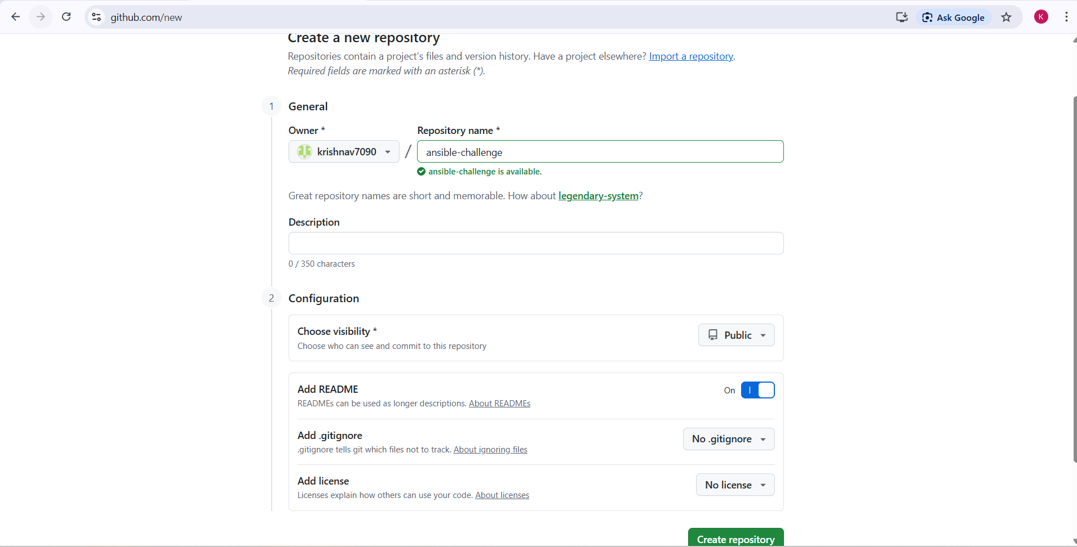
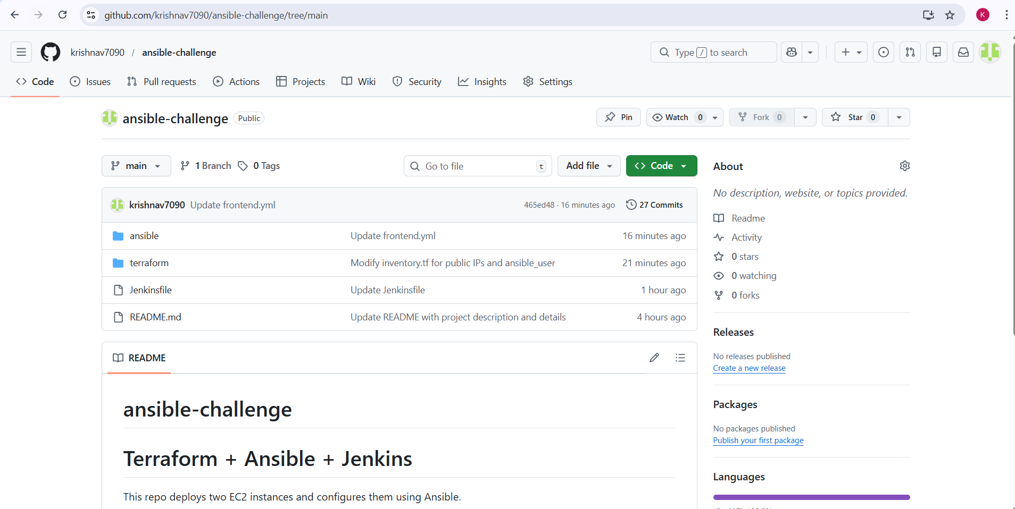
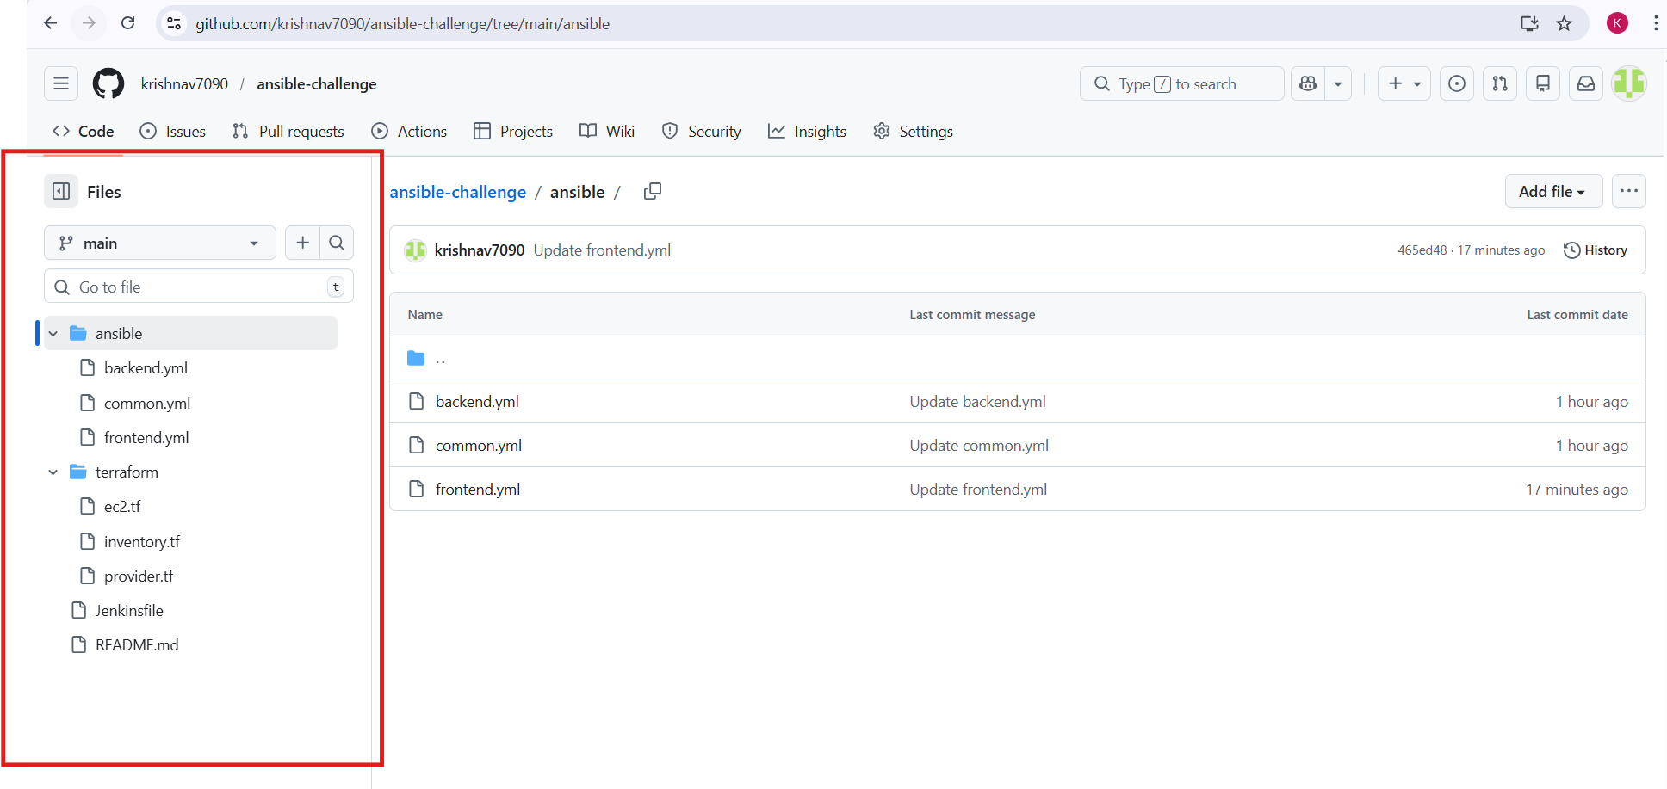
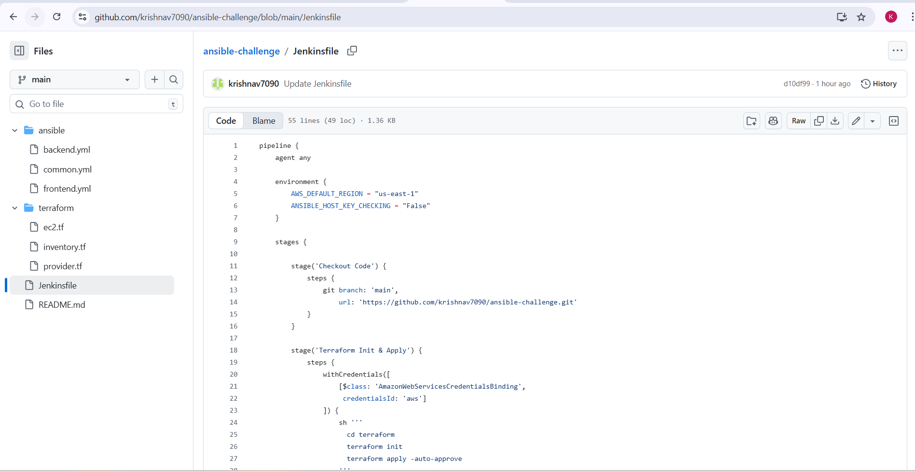
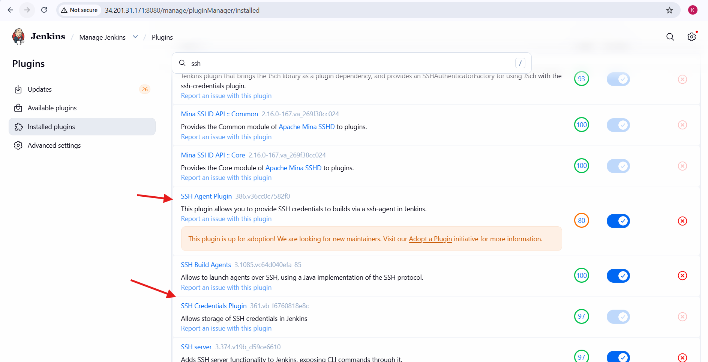
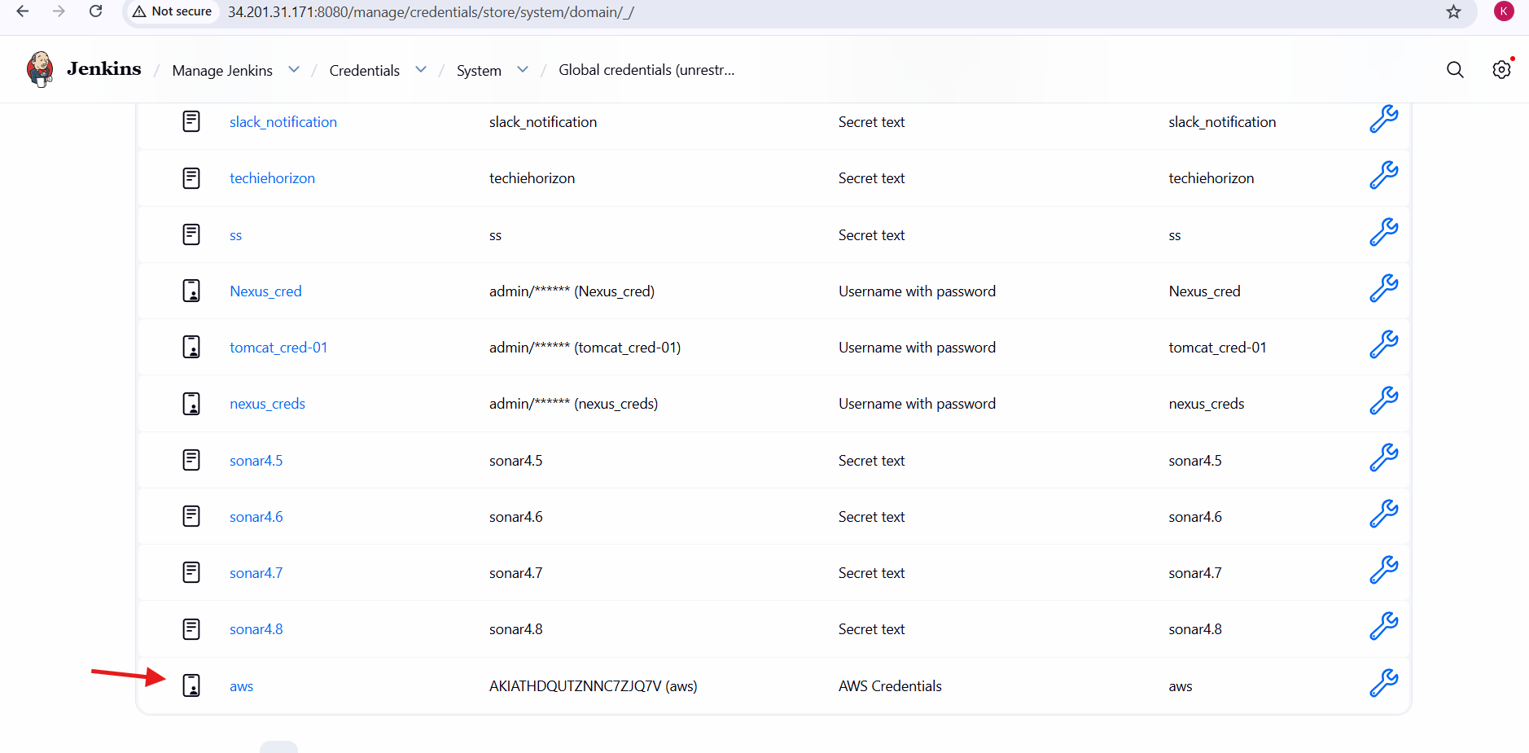
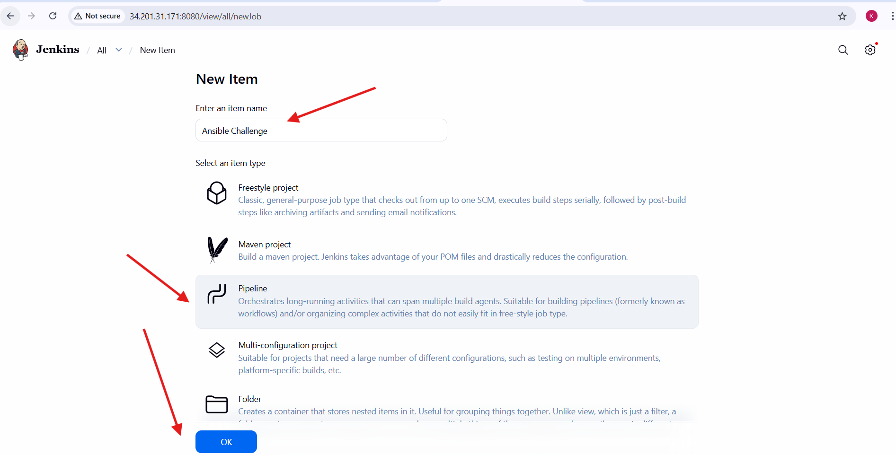
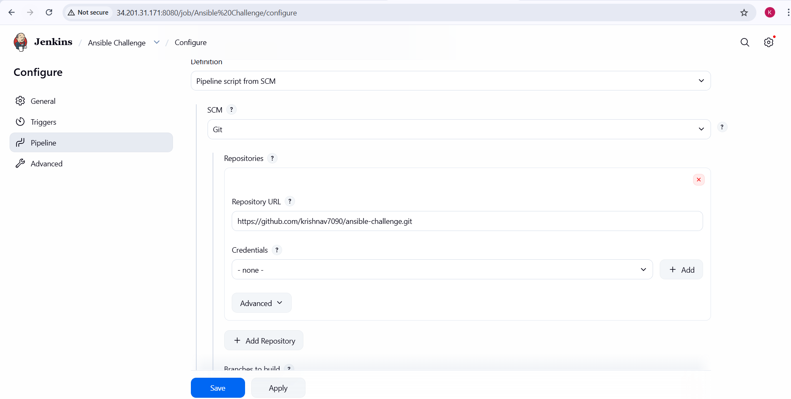
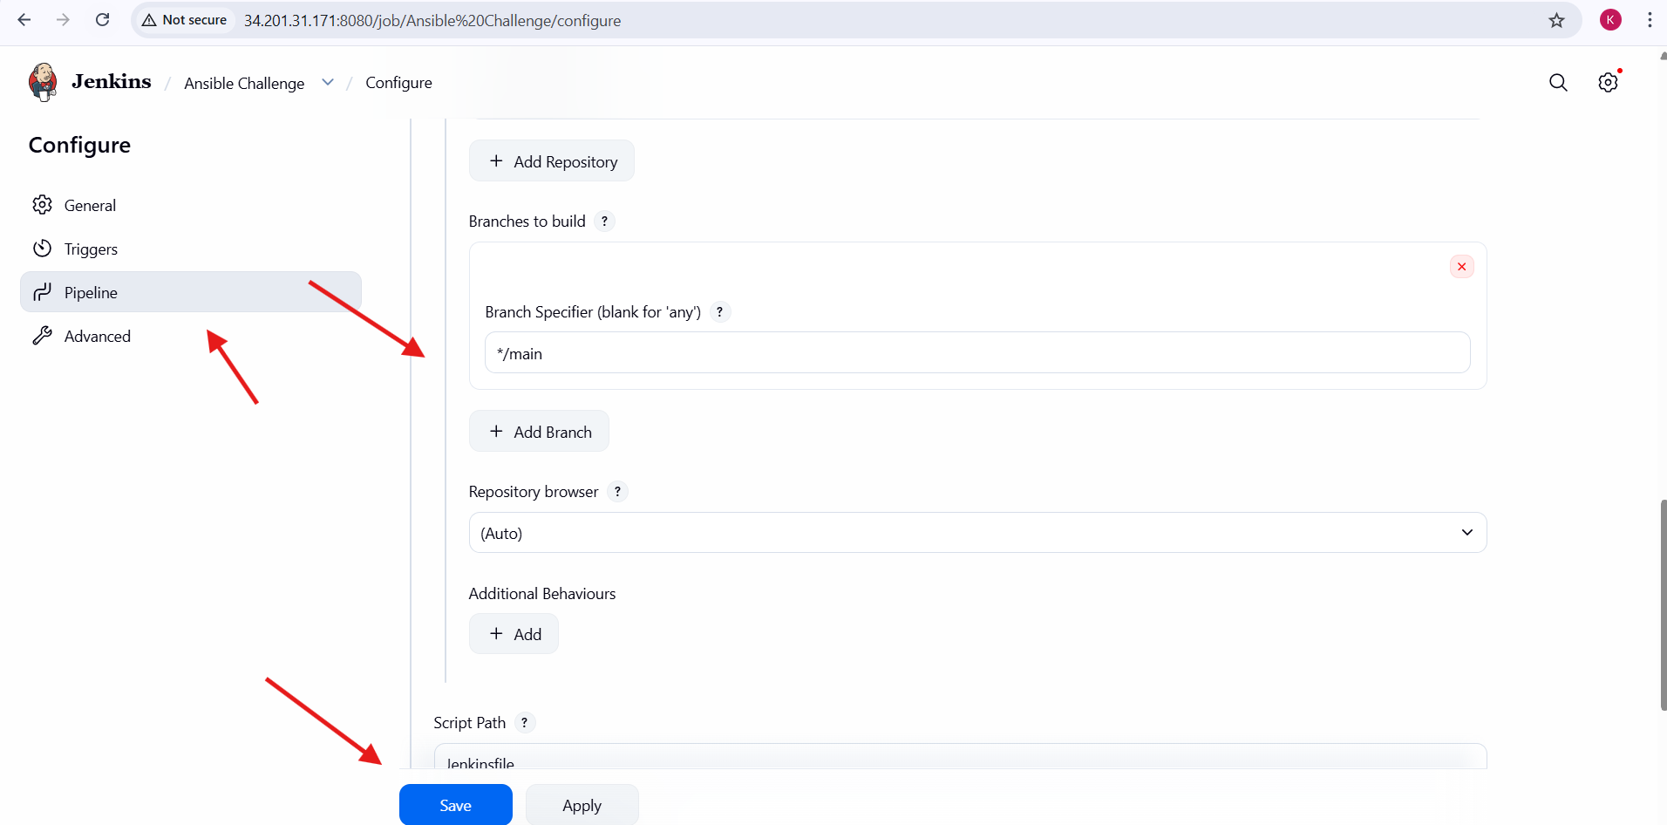
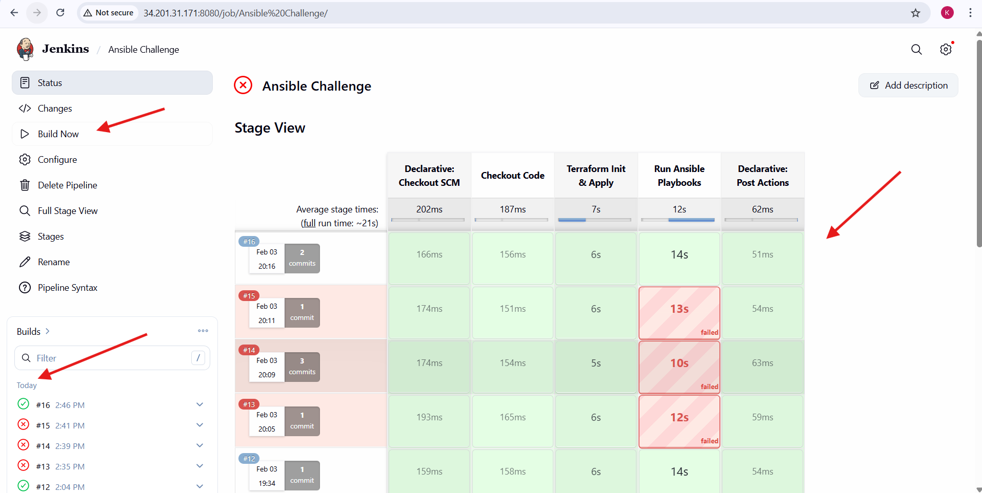

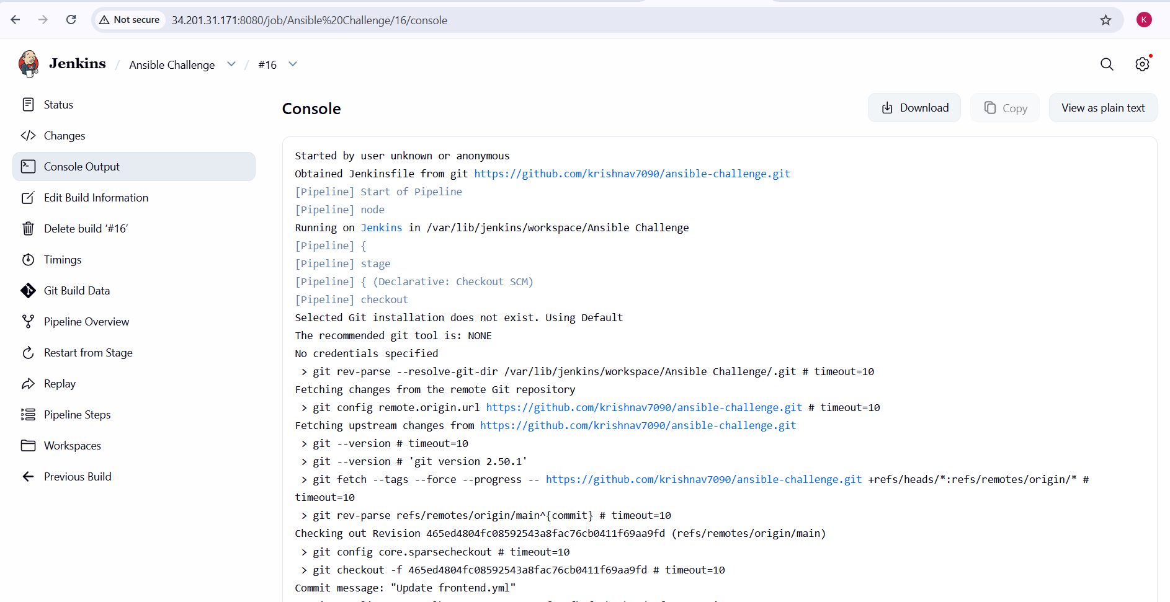
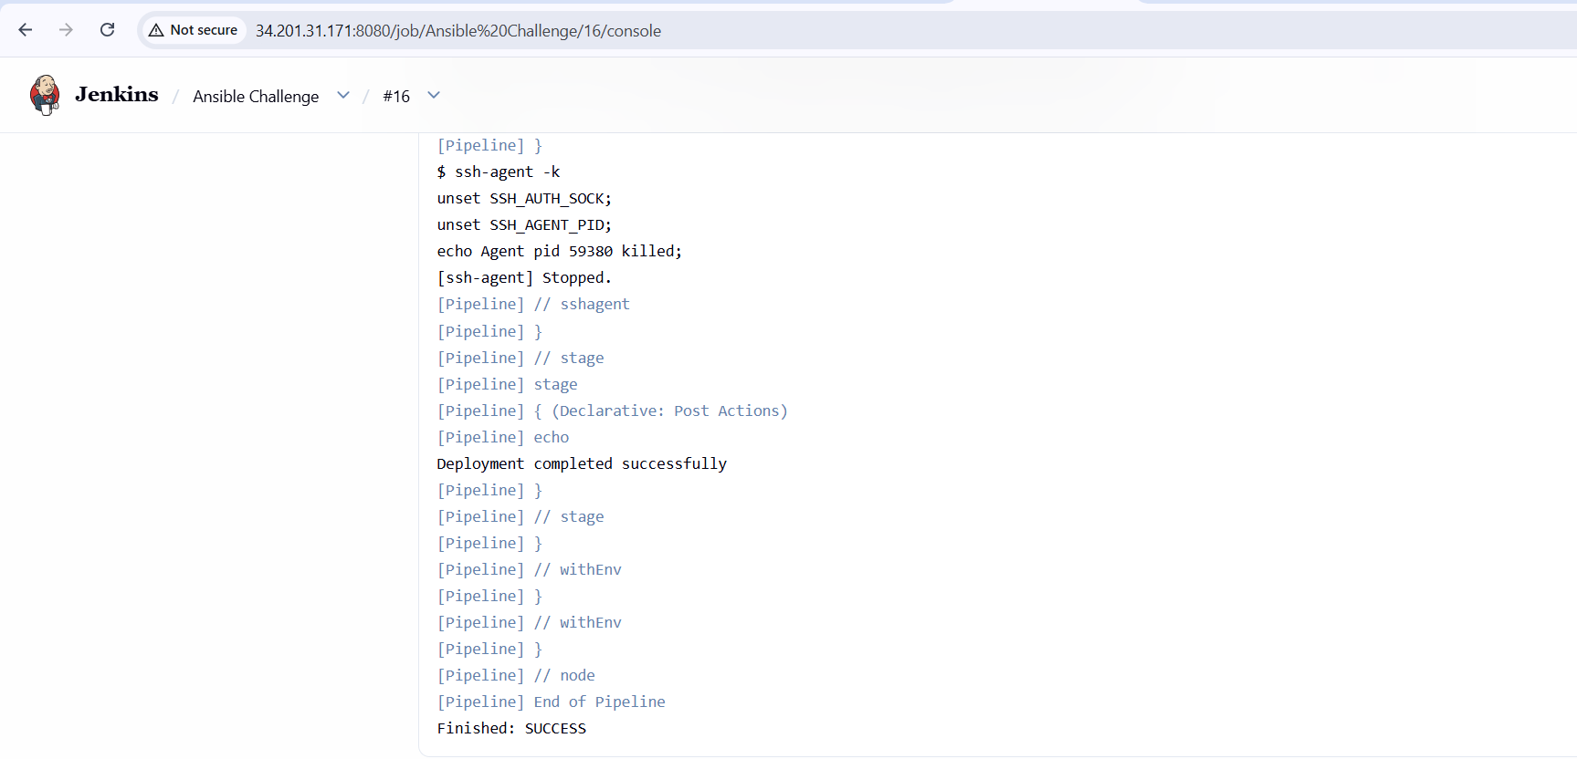
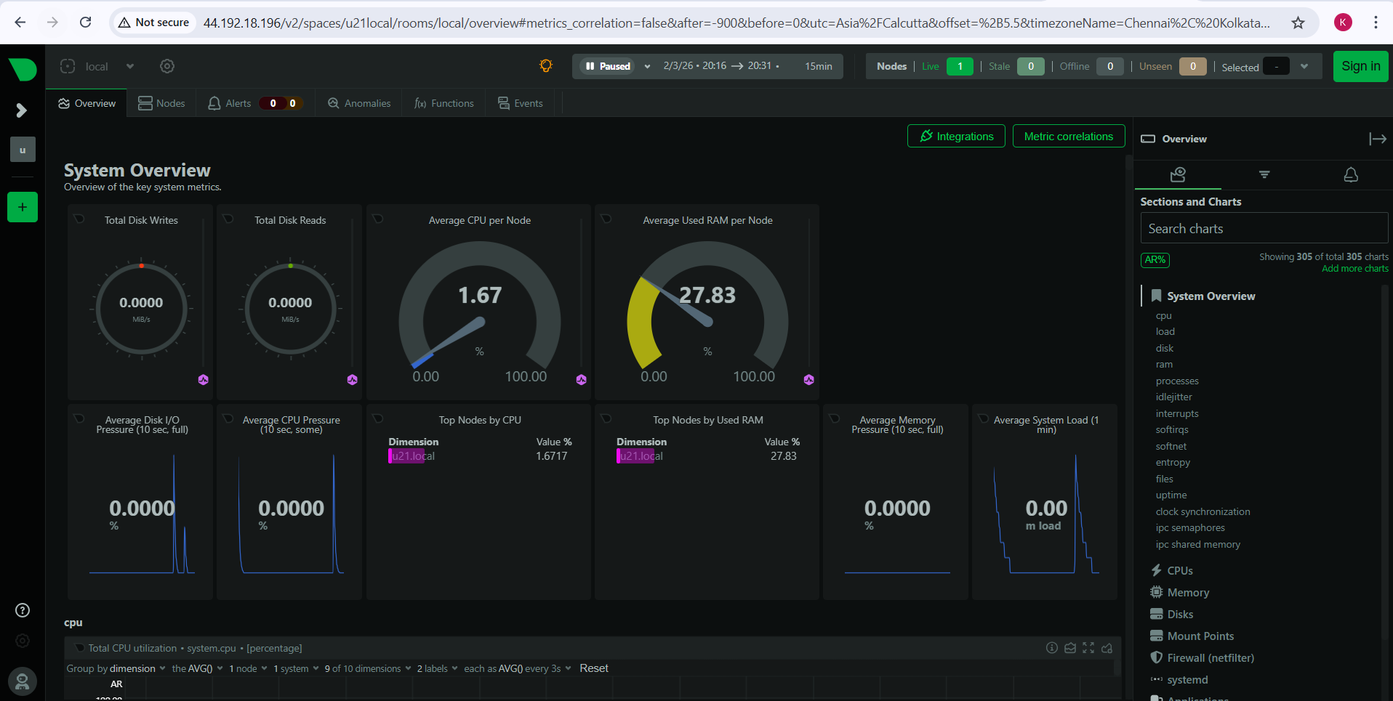

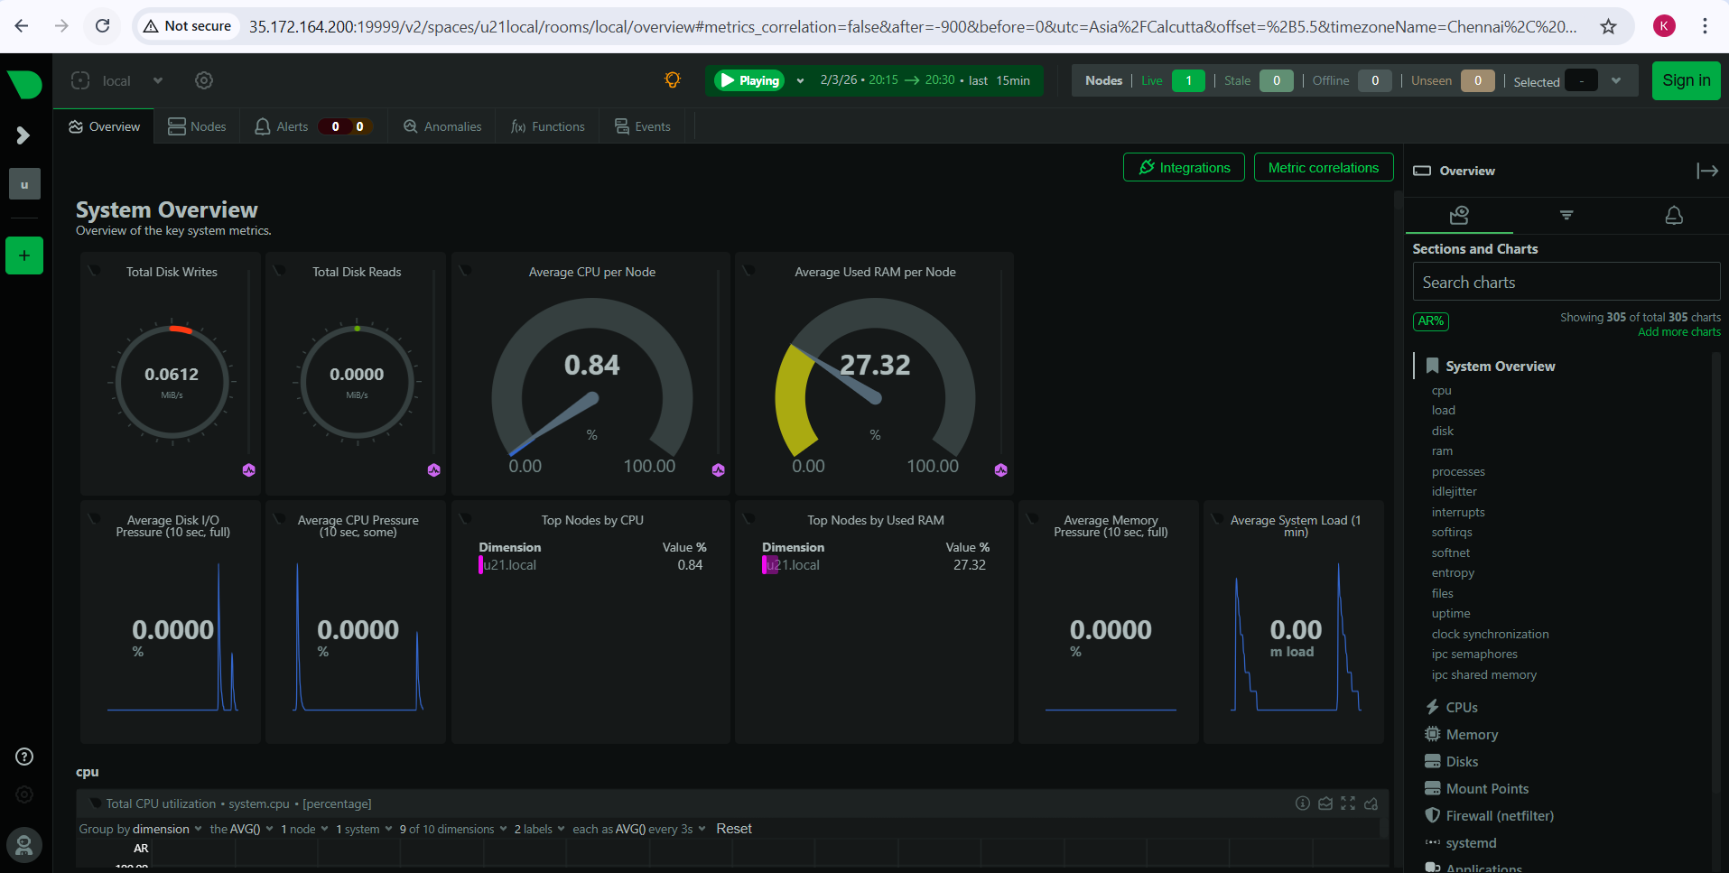

Errors Faced:
- SSH Permission Denied
  - Ansible could not connect to EC2 instances.
  - Cause: ansible_user was missing in inventory.
  - Fix: Added correct users (ec2-user, ubuntu) in Terraform inventory.
- Ansible Hosts Unreachable
  - SSH connection timed out.
  - Cause: Private IPs used while Jenkins was outside the VPC.
  - Fix: Used public IPs for SSH access.
- Undefined Variable Error
  - Error: backend_ip is undefined.
  - Cause: Variable not passed correctly from inventory.
  - Fix: Defined backend_ip under [backend:vars] and referenced it properly.
- Netdata Port Not Accessible
  - Netdata UI not opening on port 19999.
  - Cause: Netdata bound to 127.0.0.1.
  - Fix: Changed bind IP to 0.0.0.0 and restarted Netdata.
- 502 Bad Gateway (Nginx)
  - Frontend showed 502 error.
  - Cause: Nginx could not reach backend Netdata.
  - Fix: Fixed Netdata binding and reloaded Nginx.
- Jenkins Pipeline Failures
  - Pipeline failed during Ansible stage.
  - Cause: SSH credentials and host key issues.
  - Fix: Used SSH Agent plugin and disabled host key checking.
- Ports Not Accessible
  - Services running but not reachable in browser.
  - Cause: Missing security group rules.
  - Fix: Added inbound rules for ports 22, 80, and 19999.

Conclusion:
The task was completed successfully using Terraform, Ansible, and Jenkins.
Infrastructure was automated, services were configured correctly, and monitoring was exposed through Nginx.
All issues were resolved through proper debugging, configuration fixes, and security updates.

